DV (Domain Validation)
# Source: AI Source: Provided by: [Data Path: Persons Table -> ID Column: 1, Name_En Column: Motasem Essam] -> From: [ChatGPT] on [1/18/2026]
DV (Domain Validation) is the basic level of SSL/TLS certificate validation. It confirms only one thing: that you control the domain name the certificate is issued for.

🔐 What DV (Domain Validation) Is
# Source: AI Source: Provided by: [Data Path: Persons Table -> ID Column: 1, Name_En Column: Motasem Essam] -> From: [ChatGPT] on [1/18/2026]
- Verifies domain ownership, not company identity
- Fast and automated
- Most common type of SSL/TLS certificate
- Used mainly for encryption, not trust branding

🛠️ How Domain Validation Works
# Source: AI Source: Provided by: [Data Path: Persons Table -> ID Column: 1, Name_En Column: Motasem Essam] -> From: [ChatGPT] on [1/18/2026]
The Certificate Authority (CA) checks that you control the domain by one of these methods:
- Email verification
  - CA sends a code to admin@, hostmaster@, etc.
- DNS record validation (most common)
  - You add a temporary TXT record to your DNS
- HTTP/HTTPS file validation
  - Upload a verification file to your web server
If the check passes → certificate is issued.

📍 Where DV Certificates Are Used
# Source: AI Source: Provided by: [Data Path: Persons Table -> ID Column: 1, Name_En Column: Motasem Essam] -> From: [ChatGPT] on [1/18/2026]
- Personal websites
- Blogs
- Small business sites
- APIs
- Internal tools
- Development & staging environments

✅ Advantages
# Source: AI Source: Provided by: [Data Path: Persons Table -> ID Column: 1, Name_En Column: Motasem Essam] -> From: [ChatGPT] on [1/18/2026]
- Issued in minutes (sometimes seconds)
- Fully automated
- Free or low cost (e.g., Let’s Encrypt)
- Strong encryption (same as OV/EV)

⚠️ Limitations
# Source: AI Source: Provided by: [Data Path: Persons Table -> ID Column: 1, Name_En Column: Motasem Essam] -> From: [ChatGPT] on [1/18/2026]
- Does not verify business or organization identity
- No legal or company information in certificate
- Not ideal for high-trust or financial websites

🧠 DV vs OV vs EV
# Source: AI Source: Provided by: [Data Path: Persons Table -> ID Column: 1, Name_En Column: Motasem Essam] -> From: [ChatGPT] on [1/18/2026]
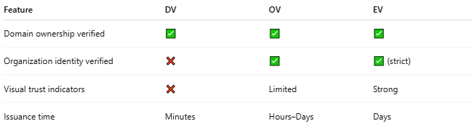
Feature | DV | OV | EV
Domain ownership verified | ✅ | ✅ | ✅
Organization identity verified | ❌ | ✅ | ✅ (strict)
Visual trust indicators | ❌ | Limited | Strong
Issuance time | Minutes | Hours–Days | Days

🔒 Security Note
# Source: AI Source: Provided by: [Data Path: Persons Table -> ID Column: 1, Name_En Column: Motasem Essam] -> From: [ChatGPT] on [1/18/2026]
🔐 Encryption strength is the same for DV, OV, and EV.
The difference is identity assurance, not cryptography.

One-line summary
# Source: AI Source: Provided by: [Data Path: Persons Table -> ID Column: 1, Name_En Column: Motasem Essam] -> From: [ChatGPT] on [1/18/2026]
DV (Domain Validation) SSL certificates prove domain ownership and enable HTTPS—but do not verify who owns the organization behind the site.

